FOR ADMISSION TO
Advanced Post Graduate Diploma in Emergency Care (APGDEC)
THE ACADEMIC YEAR
2015 – 2016
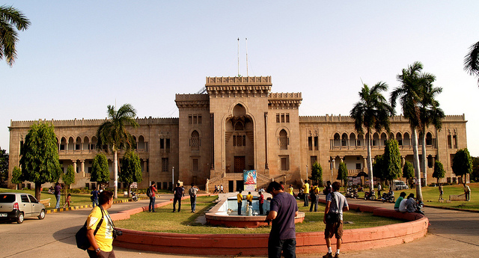

GVK Emergency Management and Research Institute
Devar Yamzal, Medchal Road, Secunderabad – 500 078
Off: 040 – 2346 2600 M: + 91 – 888 644 0593, + 91 – 916 063 3313
www.emri.in
GVK Emergency Management and Research Institute: Telangana: Secunderabad - 078
Advanced Post Graduate Diploma in Emergency Care course
For The Academic Year 2015 – 16
IMPORTANT DATES TO REMEMBER
1 | Download Application Form | www.emri.in
2 | Download Prospectus | http://www.emri.in/training-programs/APGDEC.pdf
3 | Last date for submission of print out of filled – in application along with Enclosures | 15th June 2015 (Monday)
4 | Enclosures | - Demand Draft  - Degree Certificate  - Study Certificate  - Higher Secondary Mark Sheet  - Transfer Certificate  - Migration certificate
5 | Demand Draft (DD) | For Rs. 500  In Favour of –  “GVK Emergency Management and Research Institute, Secunderabad”
6 | Date and Time of Entrance Examination  Reporting time at the Entrance Test Centre | 21st June 2015 (Sunday)  From 10.00 AM to 12.00 Noon  By 9.00 AM sharp
7 | Date of release of results | 21st June 2015 (Sunday)
8 | Date of Counseling | 21st June 2015 (Sunday)
9 | Last day for Admission | 1st July 2015 (Wednesday)
10 | Last day for Payment of Admission Fee | On or Before 1st July 2015 (Wednesday)
11 | Commencement of Classes | 15th July 2015 (Wednesday)

Note:
- No further Notification will be issued by the Institute/Organization unless there is any change in the schedule. No Individual intimations will be sent.
- If the candidate faces any difficulty for submitting the application contact
Mobile: +91 888 644 0593, +91 916 063 3313 Off: 040 – 2346 2600
- Application forms received without copies of the required Certificates, without signature at declaration area, incomplete applications, applications received after last date & time and applications of ineligible candidates will stand automatically rejected.
- The Institute/Organization holds no responsibility for Postal delays / Loss in Transit.
- An in-eligible candidate obtaining rank in the Entrance Test does not make him/her eligible for admission.
- The fee paid by the applicants is not refundable under any circumstances.

GVK Emergency Management and Research Institute
Devar Yamzal, Medchal Road, Secunderabad – 500 078
Off: 040 – 2346 2600 M: + 91 – 888 644 0593, + 91 – 916 063 3313
www.emri.in

